CV 1: <Shouvik Mukherjee> (Proposed Expert)
- Proposed Position | xx
- Name of the Firm | Deloitte Touche Tohmatsu India LLP
- Name | Shouvik Mukherjee
- Current Residential Address | Flat No: L3, 5th Floor, Tower 7, Eastern High Apartments, Action Area – I, New Town, Kolkata – 700156  Mobile: +91-8051064970 E-mail: shomukherjee@deloitte.com
- Date of Birth | 16 August 1992 | Citizenship | Indian
Type of Government ID | Passport | ID Number | L6919775

- Education
School, college and/or University Attended | Degree/ Certificate | Date Obtained
Xavier Institute of Management, Bhubaneswar | MBA (Business Management) | 2018
National Power Training Institute,  Durgapur | B.Tech (Power Engineering) | 2015

- Membership in Professional Associations | NA
- Other Relevant Training | NA
- Countries of Experience | India

- Languages
Language | Speaking | Reading | Writing
English | Good | Good | Good
Hindi | Good | Good | Good
Bengali | Good | Good | Good

- Employment Record
From/To | Employer | Positions held
Jul 2019 to present | Deloitte Touche Tohmatsu India LLP | Current Position : Senior Consultant  Position Held : Consultant
Jun 2018 to Jul 2019 | Ernst and Young Global Delivery Services India LLP | Position Held : Analyst
Aug 2015 to May 2016 | Thermax Limited | Position Held : Graduate Engineer Trainee

Key Project Experience

- Detailed Task Assigned | - Details of Assignments
As per TOR | Name of assignment: Central Project Monitoring Unit  Year: Jan 2020 – Sep 2023  Location: Jharkhand, India  Client: Jharkhand Bijli Vitran Nigam Limited (JBVNL)  Position Held: Team Member  Brief description of responsibilities handled:  - Strategic offering along with program management to the electricity distribution utility in multiple areas of operational improvement such as Rural-Urban electrification, scheme implementation & monitoring, Public-relations, facilitating implementation of management dashboard etc.  - Devising MBC strategy with IT integration for improving DISCOM revenue flow through improving Billing efficiency.  - Working on understanding various Capital investment proposals under the energy sector in Jharkhand for viability and implementation support  - Conceptualizing and implementing the IT based CMD Dashboard for project monitoring and maintaining it regularly with a focus on performance improvement  - Looking into database integration and handling various CRM platforms for effecting functional CMD dashboard  - Finalizing various project monitoring and MoM frameworks on behalf of CPMU which have been standardized across deliverables from JBVNL perspective  - Devising multiple publication content on operational and project related achievement in JBVNL and handling the same across JBVNL official social handle  - Devising MBC strategy with IT integration for improving DISCOM revenue flow  - Providing strategic support and guidance to other project teams/ consulting engagements in JBVNL as per necessity to maintain synergy and overall deliverable quality from the organization’s perspective.  - Supported in re-operationalization of the SAP-ERP system at JBVNL which is a high focus area of the top management through:  - Review and monitoring of project scope, objectives, and deliverables of the projects; benchmarking the progress of the projects vis-a-vis timelines.  - Participating in the “Steering Committee”, to ensure project implementation and reporting the gaps as measured against the targets to the steering committee and the top management at JBVNL.  - Strict monitoring and actionable suggestions towards Contracts management.  - Updating mechanism to escalate issues that do not get resolved by the project teams, to the steering committee.  - Maintaining of documentation, MoM and tracking action points to ensure the mitigation of risks and issues.  - Supporting JBNVL for approvals from program authorities’/funding authorities, including approval for variations, extension of time etc.
Name of assignment: Transaction advisory and monitoring of implementation of smart metering in the state of Jharkhand
Year: Jan 2021 – Present
Location: Jharkhand, India
Client: Jharkhand Bijli Vitran Nigam Limited (JBVNL)
Position Held: Team Member
Brief description of responsibilities handled:
- Preparation of feasibility report and DPR for smart meter
- Conduct feasibility for suitable communication technology for the project area.
- As-Is assessment of utility IT system and develop solution architecture for seamless integration of AMI system with it.
- Preparation of technical specification for smart meter and communication infrastructure
- Project management and monitoring of smart meter implementation works
- Tender preparation and support for bid process management
- Bid evaluation and contract award
- Application roll-out management
- Project evaluation/impact assessment
Name of assignment: IT PMO cum ICT Project Management Consultancy Services at JBVNL under JPSIP (Funded by World Bank)
Year: Feb 2022 – Ongoing
Location: Ranchi, India
Client: Jharkhand Bijli Vitran Nigam Limited (JBVNL)
Position Held: Team Member
Brief description of responsibilities handled:
- Transaction Advisory for procurement of appropriate turnkey solution for Unified MBC-CIS-MDMS on cloud.
- Project Monitoring of various IT Projects’ implementation including
- State-wide Unified MBC-CIS-MDMS solution (COTS product) which also includes SPM, MIS, DMS modules integrated with HES, SAP BI/BO, MM, HCM, AM, PM and PS modules
- 20 Lakh Smart Meter installation including HES-MDMS-CIS integration,
- Migration of SAP-ERP to cloud
- The MIS module is envisaged to deliver reports and dashboards at different levels of organization i.e., top management, middle management, and sub-division levels. Also, the solution is to fulfil the requirements of decision makers, auditors and executive staff running daily operations. The solution is to be implemented through SAP BI/BO, which will used as data warehouse and for creation of dashboards and reports.
- Consultancy to Utility throughout Project life cycle of AMR/AMI projects, Meter to Cash Digitalization projects.
- Consultancy to Utility on implementation/upgradation of IT infrastructure.
Name of assignment: Engagement of ERP Roadmap Consultant for DPL
Year: Feb 2022 till date
Location: Durgapur, India
Client: The Durgapur Projects Limited
Position Held: Team Member
Brief description of responsibilities handled:
- Assessment of Greenfield ERP implementation of S4 Hana on Cloud.
- Assess need for Customization vis-a-vis ERP products available in market
- Data reconciliation at various levels and looking into the level of data automation/ integration into SAP ERP platforms
- Preparation of Integration Strategy for existing IT/OT tools with ERP such as Plant MIS System, DCS System, Existing Financial Systems, HRMS and Payroll systems.
- Preparation of ERP Implementation Roadmap including phasing of modules, implementation models (cloud-based deployment) among others Preparation of the Request for Proposal for Appointment of the System Integrator for the ERP Modules
- Support during ERP implementation by SI and address change management requirements
- Middleware Integration of legacy application with ERP
- As-is study of following Modules covered under the scope of ERP development:
- Human Resource Management – Master Data Preparation
- Material Management
- Sales and Distribution Management
- Financial Accounting and Management
- Preparation of Bid Document for e-Tendering.
Name of assignment or project: Institutional Development and Human Resource Management of WBPDCL
Year: 2023 – Ongoing
Location: Kolkata, West Bengal
Client: WBPDCL
Position held: Team Member
Activities Performed: Shouvik is working as Team Member for Implementation for performance management system on cloud:
- Design and implement performance management system for generation Utility
- Design and implement KPI’s for employees of generation utility plants and corporate office
- Functional Design
- Middleware Integration of the on-cloud PMS system with SAP ERP
- Wireframe Design for Forms/Pages
- Prepare As-Is Document
- Prepare Functional Specification Design
Name of assignment or project: Support in deployment of NFMS Platform
Location: Gurugram, India
Client: RECPDCL
Year: 2022 – Ongoing
Position held: Team Member
Activities Performed: Shouvik is working as Metering and Power sector SME, he is working on below:
- Support to RECPDCL in gathering the data from the utilities
- Support for readiness of integration documents based on parameters available in Feeder meters for AMR/ RT-DAS/SCADA/AMI systems
- Support in preparation of Guidance note for the State Utilities
- Support in finding the as-is scenario for Feeder Monitoring system
- Support in review of Project Plan
- Oversee implementation of Energy Accounting till 11kV feeder across states
Name of assignment: Consulting Services - Program Management Support to MoP, GoI
Year: Aug’2022 – Nov’2022
Location: RECPDCL HO, India
Position Held: Team Member
Client: RECPDCL, India
Brief description of responsibilities handled:
- Transaction Advisory and Technical Project Management on implementation of IT -OT in DISCOMs (Pan India) and National Feeder Monitoring Solution including procurement of the most appropriate solution.
- The National Feeder Monitoring Solution envisages to establish Central platform for monitoring of all Feeders across the country which shall be further integrated to NPP and other legacy system as per the requirement.
- The solution to provide analytical results based on different feeder parameters like operational parameters, outage statistics, consumers affected, geotagging of assets etc via integration with over 85 different utilities to accumulate the metering data from different platforms like SCADA, RTDAS, MDMS, HES etc. on a central platform, perform the Validation, Estimation and Editing (VEE) based on business rules and provide high-level view of the feeder operations and utility performance across the country.
- The solution includes integration with multiple MDAS and other heterogenous systems through a Middleware to create a data warehouse for data analytics and dashboard visualization.
- Drafting frameworks for meter/modem installation/replacement projects for REC/RECPDCL funded projects w.r.t compliance issue on material /technology /integration for RFMS and UFMS.
Name of the Assignment: Consultancy Service for ERP for STELCO, Maldives
Year: Jan 2020 – Dec 2022
Location: Maldives
Client: STELCO (Govt. owned generation and distribution utility in Maldives)
Position Held: Team Member
Activities Performed:
- As-is assessment of the existing business processes vis-a-vis. best in class practices (generation, transmission and distribution planning, network management, customer service, fuel management & pilferage reduction, among others)
- Assess ways of integrating existing processes, systems with proposed ERP system
- Design of to-be business processes required for affecting changes
- Assess need for Customization vis-a-vis ERP products available in market
- Develop functional requirements specifications which are critical for development of RFP and Cost-Benefit analysis
- Preparation of Cost Benefit Analysis for proposed ERP systems
- Preparation of the Request for Proposal for Appointment of the System Integrator for the ERP Modules as well any identified OT Tool, 3rd Party Software by STELCO
- Preparation of ERP Implementation Roadmap including phasing of modules, implementation models (capex / opex / cloud based deployment) among others
Name of the Assignment: Detailed Project Report for Sikkim Power Sector Development Project
Year: Feb 2021 – Dec 2022
Location: India
Client: Asian Development Bank / Power Department, Government of Sikkim (Distribution utility of the state government)
Position Held: Power Sector Expert
Activities Performed:
- Provide full support to the Project Management Unit (PMU) of the Power Department, assess the existing transmission and distribution infrastructure in the stake of Sikkim.
- Detailed review of the IT system of the Power Department including the billing and CRM system installed under RAPDRP.
- Preparation of detailed project report on some of the key intervention areas like digitization of metering, billing and collection processes, roll-out of Enterprise Resource Planning (ERP) platform for digitizing day-to-day business activities such as finance, material procurement, GR activities etc and customer relationship management (CRM).
- Detailing requirement to establish a customer call center in each circle solely dedicated to catering the needs of that circle along with a refreshed CRM system at the Power Department.

- Certification

I, the undersigned, certify to the best of my knowledge and belief−

(i) this CV correctly describes my qualifications and my experience | Yes
(ii) I am not a current employee of the Executing or the Implementing Agency; | Yes
(iii) In the absence of medical incapacity, I will undertake this assignment for the duration and in terms of the inputs specified for me in Form TECH-6 provided team mobilization takes place within the validity of this proposal; | Yes
(iv) I was not part of the team who wrote the terms of reference for this consulting services assignment | Yes
(v) I do not have conflict of interest in accordance with ITC 3.0; | Yes
(vi) I am not subject to any national or international sanctions, temporary suspension or debarment by ADB or other multilateral development banks (MDB); | Yes
(vii) I certify that I have been informed by the firm that it is including my CV in the Proposal for PMC for Supervision of Implementations of ERP and RMS at NEA. I confirm that I will be available to carry out the assignment for which my CV has been submitted in accordance with the implementation arrangements and schedule set out in the Proposal. | Yes
(viii) I have not been found guilty or convicted of any violation of law that is not a minor traffic violation | Yes
(ix) I can accept payments through the international banking system or otherwise discharge ADB’s obligation upon initiation of wire transfer | Yes
(x) I understand that it is my obligation to notify the Client and ADB should I become subject to any national or international sanction, including becoming ineligible to work with ADB or other MDBs, cannot accept payments through the international banking system, should integrity issues including conflict of interest arise and/or should we or the proposed consultant be convicted of an offence excluding minor traffic violations | Yes

I, as the authorized representative of the firm submitting this Proposal for the Selection of PMC for Supervision of Implementations of ERP and RMS at NEA (Institutional Strengthening Project, Finance Directorate, NEA), certify that I have obtained the consent of the named expert to submit his/her CV, and that s/he will be available to carry out the assignment in accordance with the implementation arrangements and schedule set out in the Proposal, and confirm his/her compliance with paras (i) to (v) above.
I understand that any wilful misstatement described herein may lead to my disqualification or dismissal, if engaged.

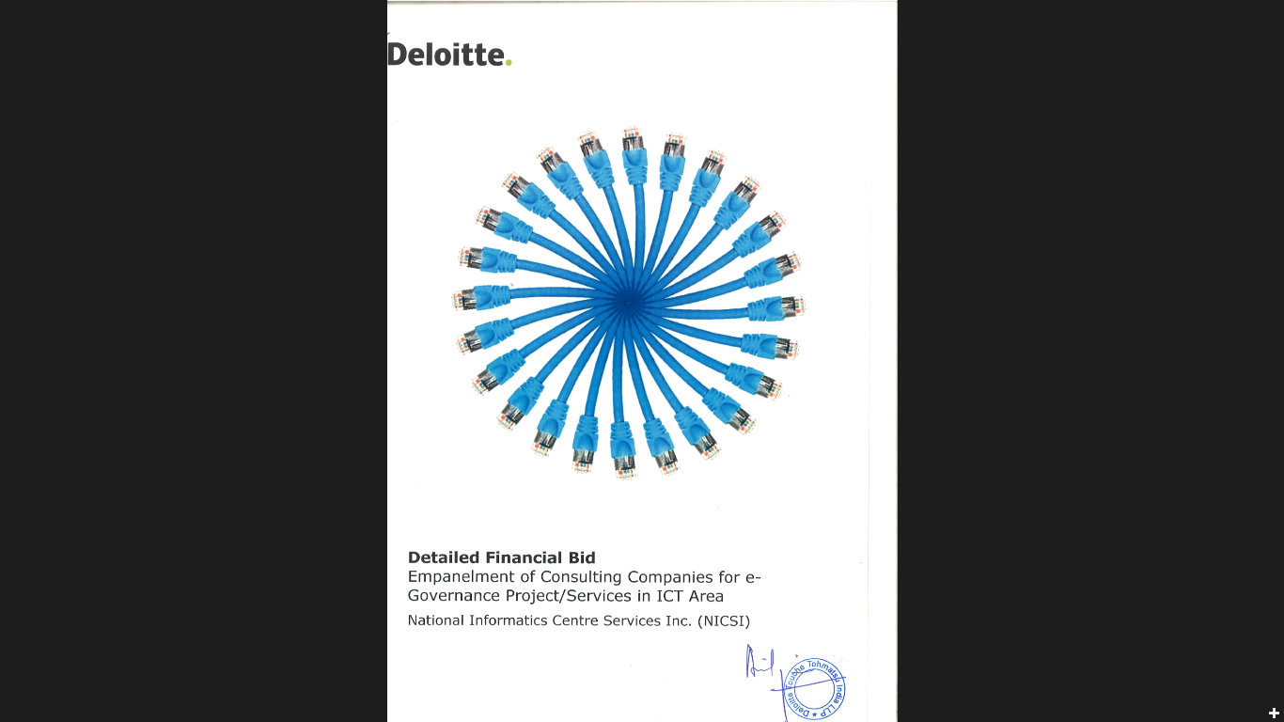

Signature of the Authorized Representative of the Firm Date: 03 January 2024

